DIGITAL MARKETING

# ASSIGNMENT

|  |  |
| --- | --- |
| Reg No | 960220106104 |
| Team ID | NM2023TMID09736 |
| NM ID | FB79D5B306697C6A75548F19F3023844 |
| Date | 21-10-2023 |

**1. Create a blog or website using blogs spot and WordPress. Customize the theme design and post new article with 500 words.**

Blog Link:

<https://www.blogger.com/blog/posts/7014460158830521803>

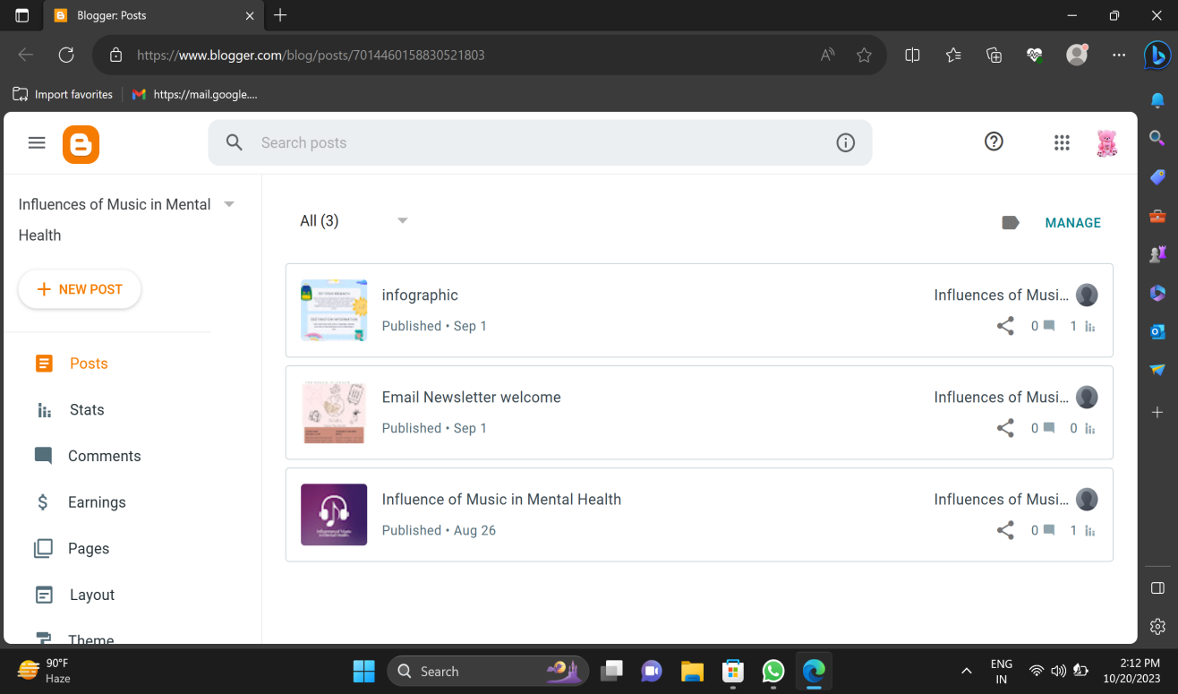

Word Press: <https://aboutmentalhealth2023.wordpress.com/2023/10/06/influence-of-music-on-mental-health/>

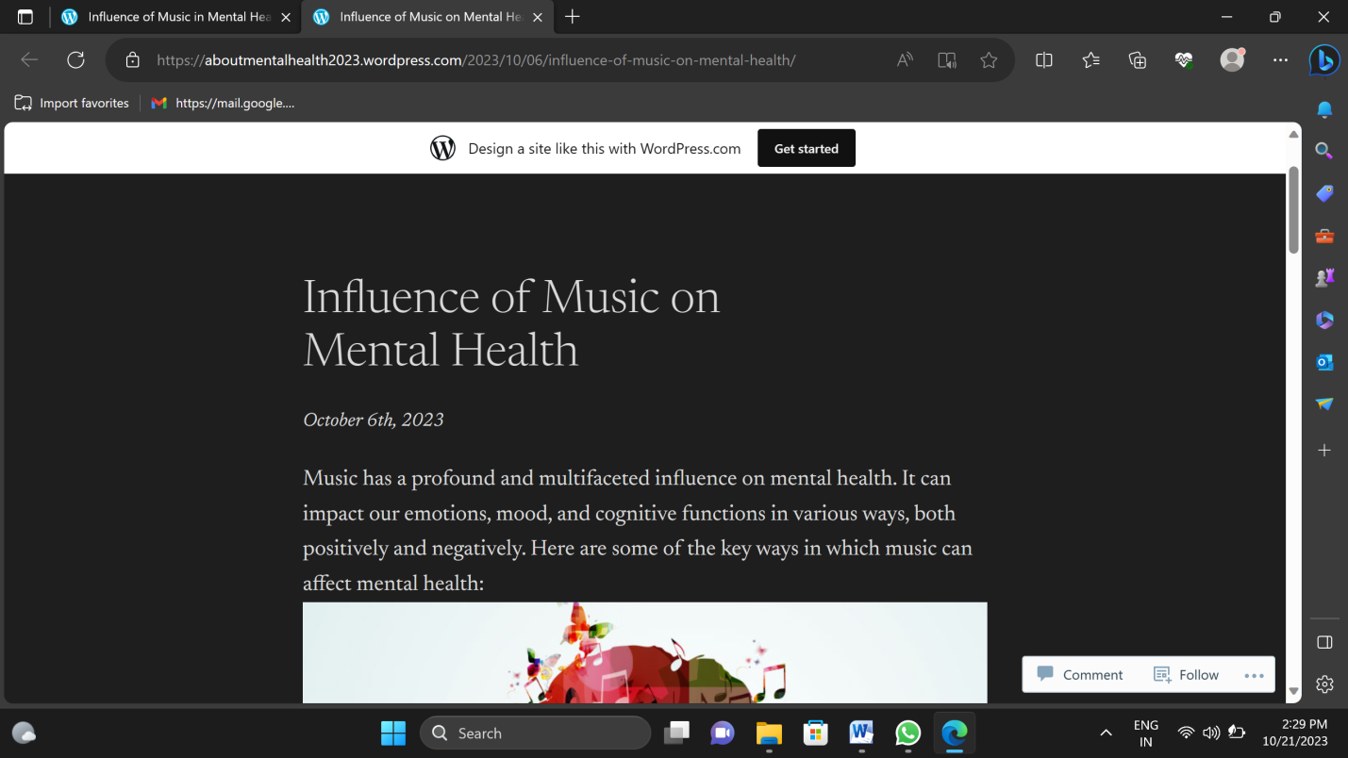

2. Create a New Facebook Business Page and post one social media poster for your brand

Facebook Business page Link: <https://www.facebook.com/profile.php?id=61550755460620&mibextid=ZbWKwL>

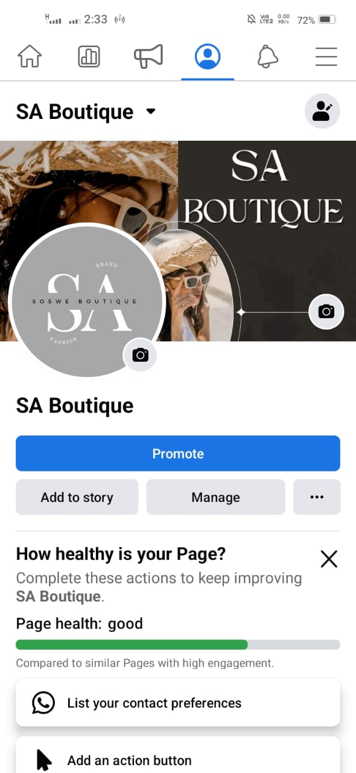

3.Create and design a social media advertisement poster using canva.

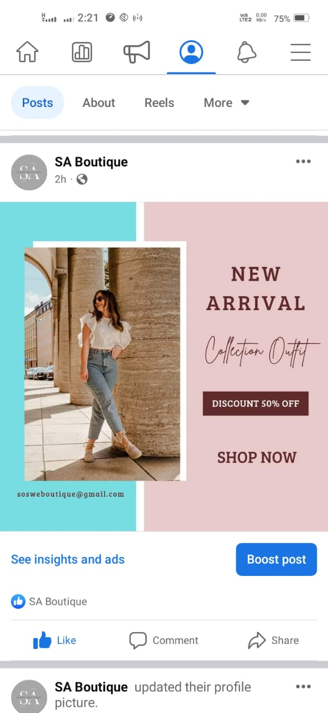

4.Create email newsletter design using mailchimp or canva

Email newsletter link: <https://www.blogger.com/blog/post/edit/7014460158830521803/429721406867365520>

